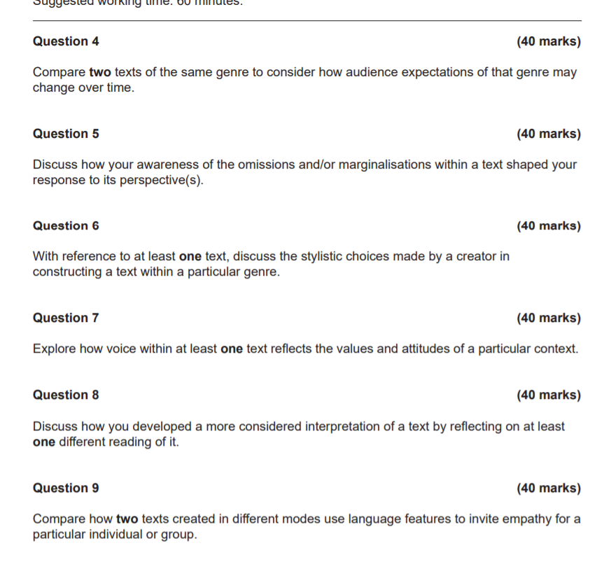

You could look at Q4 in terms of the old Zombie movies we looked at with their racism and sexism and it all being about protecting white male privilege and then look at Girl With all the Gifts and how the zombies actually replace the old system.

Q5 You could look at how the main character gives voice and privileges a group marginalised by society – in and out of the film and explore how the film shows both her marginalisation (at the start) and then the shift. You could also explore the way our anthropocentric view marginalises nature and privileges human achievement with all its capitalist icons and this film reverses that and puts nature back in the centre – also works for Tales of the Inner City, Yellow Wallpaper and Fall River – They all give voice to the marginalised while also showing how the privileged dominate.

Q6 You can look at how any of the texts play with genre / film / short story conventions for effect – All 4 texts play with genre and have a very distinctive style / aesthetic / look about them that draws attention to the ideas they are conveying.

Q7 Yellow Wallpaper and Fall River are perfect for this – You could also use Girl and Inner city and look at how the different characters / people act as a mouth piece for our anthropocentric / science based / capitalist attitudes.

Q8 You can read Girl with all the gifts as a tale about surviving zombies or you could develop a more interesting reading by reading it as a comment on our anthropocentric / patriarchal / capitalist modern society and read it as a warning that nature will find a way to put us in our place. Same for Inner City.

Q9 You could look at Girl and Iphigenia and look at how visual language works compared to written language

Hope that helps give you a pathway into those kinds of questions.